**C++ Snake Game**

Built with Visual Studio 2017

And SFML

Thomas Knight

**Game Controls**

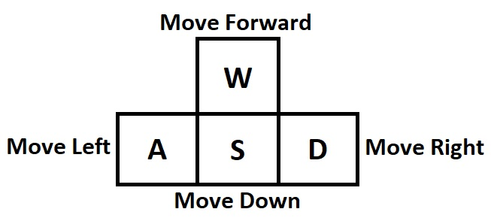

**Problems I’ve had and solutions**

There were a number of problems I had with programming this game. One of the more recent issues I had was loading up the font for the text. After spending a lot of time trying to figure it out, I found out that it wouldn’t load because of the way I had set up SFML on my laptop. After changing the settings around it ended up working perfectly.

Another issue that I had was that the snake would die when being forced downwards on the surface if the player was spamming any key other than down. This was because the order I had programmed it meant that the snake could go back on itself, and because of how the collision is programmed it would immediately die. To solve this, I made changes to the changeDirection function so that if the snake was on the surface it would not be able to change to any other direction than down, meaning it could not go back on itself.

Finally, one major problem I had near the start of making this game was how I was originally programming the movement. Originally, I was trying to have each individual part change positions, much like how a platformer would work. However, this ended up being very complex and cause a number of issues, especially with lists, vectors and how they work. To solve this, I decided to have it push new snake parts to the front and pop parts at the end, which ended up being very simple and worked well with the 2D vector.

**Reflection**

I believe I learned a lot through this ICA, such as how to use lists and organise my code. At one point I had to program debugging outputs into my code to track down certain bugs that were difficult to find, which taught me that next time I should build my code with debugging in mind at the start, as it took so long to implement it.

I found that structuring it as a 2D vector instead of snapping SFML shapes to a grid was a unique learning experience, as I had to figure out how to put it together by myself since most of the advice on Blackboard was specific towards the second method I mentioned. I felt like although it was difficult to start with, it was easy to use later on and made putting together the game really easy.

If I was to do this ICA again, I would probably structure it by using SFML shapes and moving those about directly, rather than creating a 2D vector, just so I can experience how to program that together and learn the various SFML functions that I would need to use. Other than that, I’m pretty happy with how this ICA went.